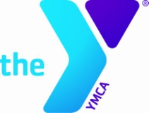
Registration and Permission Slip
21st Annual Girls & Sports Day
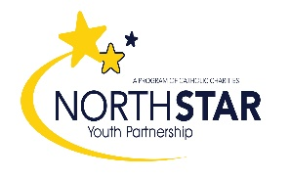
Saturday, September 30th, 2023

12:00pm - 5:30pm
James Family Prescott YMCA ● 750 Whipple St, Prescott
Cost: $15.00 Pre-Registration/$20.00 Day of Event
(no refunds, transfers, or credits)
Please register early as we expect to fill all 150 spaces
Drop off or mail registrations to the Prescott YMCA, 750 Whipple St. Prescott, AZ 86301

First Name_____________________ Last Name _____________________
Address_____________________________________ City_______ Zip_______
Age____ Birthdate_____/______/_____ Age Group (circle one): 7-8 9-10 11-14
School Attending___________________________________ Grade_______
Email__________________________________________ (for information and reminders)
Mother’s Name___________________________
Home #________________ Work#________________ Cell/Pager________________
Father’s Name____________________________
Home #_________________ Work#________________ Cell/Pager_______________
Phone # and contact name day of event____________________________________
Allergies or conditions that may limit activity: _______________________________
How did you hear about Girls & Sports Day? ________________________________
Previous Participant? (circle) Yes No If yes, how many years? _______
For grant purposes only - Ethnicity _____________
I acknowledge that participants cannot be guaranteed a risk-free environment from COVID-19 during this North Star Youth Partnership/Prescott YMCA event. ____ (Initial)

My daughter has my permission to participate in Girls & Sports Day. In case of accident, injury or illness, the Prescott YMCA has my authorization to secure, at my expense, such medical treatment as is deemed necessary. I understand that I will not hold the Prescott YMCA or North Star Youth Partnership responsible for accidents or injury that may occur during the activities. I understand that the Prescott YMCA does not provide medical insurance for participants. I also authorize the Prescott YMCA / North Star Youth Partnership to photograph and / or video my daughter while participating in Girls & Sports Day activities for future display and publications in order to promote this program. I also authorize my daughter to answer any survey questions asked throughout the day.
Parent / Guardian Name (printed)_______________________________________________________________
Parent / Guardian Signature________________________________________________ Date_______________
***OVER***
James Family Prescott YMCA 750 Whipple St. Prescott, AZ 86301 928-445-7221 prescottymca.org
North Star Youth Partnership 434 W Gurley St Prescott, AZ 86301 928-708-7214 northstaryouth.org
